20 | 19 | 18 | 17 | 16 | 15 | 14 | 13 | 12 | 11
Ski LODGE
24
23
22
21
25
26
27
28
29
30
31
32
33
34
35
36
37
38
39
61
60
59
58
57 | 56 | 55 | 54 | 53
62 | 63
68
67 | 66 | 65
69
70
71
5 | 4 | 3 | 2
40
41
42
43
44
Lake
73
Lake Lyell Site Map
= powered sites
1
45
BBQ PLAYGROUND TOILETS
BOAT RAMP
CAR PARK

Office Kiosk
Showers Toilets

6 | 7 | 8 | 9
52
51
50
49
48
47
72
64
46

CAMPING GUIDELINES

The picnic area, BBQ’S and Playground open from 5am-10pm
NO ENTRY PERMITTED OUTSIDE THESE TIMES

- Campers: $30.00 per night per UNPOWERED site. $35.00 per night per POWERED site.
No water on powered sites.
- Ski Lodge: $180 per night, sleeps eight (8)
- Need to provide your own linen, pillows & towels
- For all bookings we require a 50% non-refundable deposit. Cabins are 100%.

This entitles you to one campervan/vehicle or one caravan/tent and one vehicle only for a maximum of five (5) people. Please notify staff if you have more tents/people. Fines apply for fee evasion.

- Check-in: 10.30am for camp sites and 1:00pm for cabins. Late check-in can be arranged.
Check-out: 10:00am on day of departure.

- Boom Gate Access: $7 in gold coins can be inserted in the gate or access can be paid for in office. Campers receive a gate code in office. Code expires on day of departure. Remember to press star after the four-digit code.

- BBQs: Have been provided free of charge for use by all patrons and are to be cleaned after use.

- Hot Food and drinks: Are available from office from 8am to 5:30pm.

- All Flora and Fauna are protected.

- Dogs: Restricted breeds or ‘barkers’ are not permitted. COMPANION ANIMAL ACT APPLIES. Management reserves the right to deny entry of any dog or request the removal of any dog without explanation. Dogs must always be kept on a lead under control. Please remember to pick up all pet litter.

- Noise: Please keep noise to a minimum. Noise restrictions apply after 10.00pm. No music, generators etc are to be used after this time.

- Vehicles: All vehicles must obey 10km/h max speed limit. Vehicles must not be driven off formed roads.
NO TRAIL BIKES, QUAD BIKES, DIRT BIKES, MOTORISED SCOOTERS, CHAINSAWS, FIREARMS OR WEAPONS PERMITTED AT ANY TIME.

- Drinking Water: Drinking water is available free of charge from the taps at the rear of the amenity’s buildings. This water is for patrons only and must only be used to fill a drinking water container. We cannot fill tanks in vans or mobile homes, as we are on tank water ourselves.

- Showers: $1 dollar coin for 3 minutes ($1 dollar coins only). Change is available from the office during business hours only. Please leave the showers how you would like to find them! Showers and toilets close at various times for cleaning.

- Campfires: The collection of firewood is NOT permitted. All campers must only light campfires in designated areas. No campfires below high-water levels. Bottles not to be disposed of in fires. Campers must check fire restrictions daily at the office during the fire season. Firewood is available for purchase. CAMPFIRES ARE NOT TO BE MOVED FROM THEIR ORIGINAL POSITIONS. NO NEW FIRES TO BE BUILT.

- Rubbish: No rubbish/litter is to be left on the ground or in the water. Rubbish is to be bagged and placed in the large SUEZ bins provided. The small bins are not for large bags of rubbish.
FINES APPLY FOR LITTERING AND WILL BE ISSUED WITHOUT HESITATION!

- Children: For their own safety children must always be accompanied by an adult. This includes in the playground as well as the amenities buildings. Children are not permitted to camp unless accompanied by a parent or guardian.

- Playground: Children must always be supervised by an adult. Use is at own risk. Children found unaccompanied in the playground or amenities buildings will be asked to leave. It is for their safety!
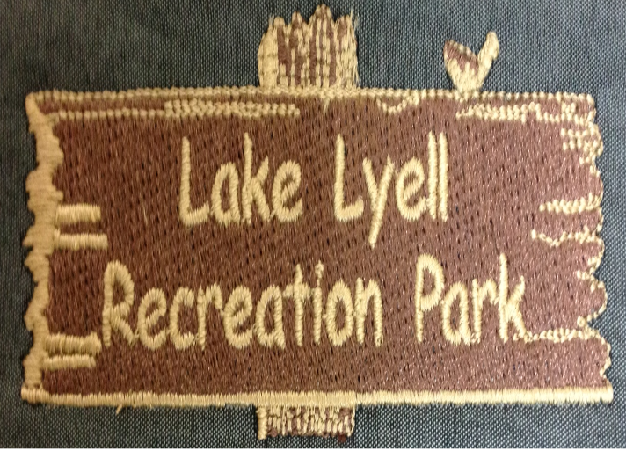

Thankyou for choosing to stay with us at Lake Lyell.
Your hosts Pete and
Stace

Please find enclosed the map and our camping guidelines.

Please ensure all members of your camping group are familiar with the camping guidelines as expulsion and/or fines apply for non-compliance.

For information or assistance please contact staff or call our office on:
Address: 578 Magpie hollow road South Bowenfels, Lithgow
Phone: 02-63556347
Email: lake.lyell@bigpond.com
Web:www.lakelyellrecreationpark.com.au
WE HOPE YOU ENJOY YOUR STAY!
Find us on Facebook & Instagram!

