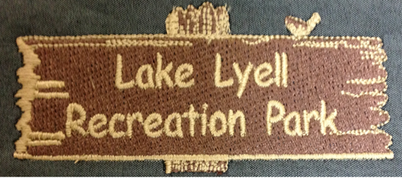

Lake Lyell Recreation Park Terms & conditions

Lake Lyell camping grounds
Check in time 10am-6pm, late check-in can be arranged on the day. Check out time is 10am.

Booking Conditions
When making a booking a 50% non-refundable deposit will be required for all non-powered and powered campsites. A 100% non-refundable deposit will be required for our cabin (ski lodge).
Cards accepted Visa & Mastercard when making a deposit.
We will allow you to move your booking once only with good reasoning. Credits are not available. You must give a 72 hour notice to change your booking once.
Long weekends and public holidays are a 3-night minimum stay, waterfront and powered sites are a minimum 2-night booking.
When making a booking you are booking a site and the facilities in the park, we cannot control our water level, quality of water along with the weather, therefore no consideration will be given to these matters when cancelling a booking.

Cancellation Policy

If a cancellation is made you will not be granted a refund of 50% deposit. When paid in full you have 48 hours before your booking to notify the office if your intention is to cancel and to be able to receive your 50% back from your full payment.
No refunds will be given for early departures. This may include poor weather or personal reasons, if you are asked to leave due to behaviour there will be no refund provided.
Lake Lyell Recreation Park Pty Ltd has the right to change or alter these T & C’s at anytime without notice.

